|  |  |
| --- | --- |
| **Ex no:4** | **WORKING WITH CONSTRAINTS** |

## Find the Solution for the following:

1.Add a table-level PRIMARY KEY constraint to the EMP table on the ID column.The constraint should be named at creation. Name the constraint my_emp_id_pk.

CREATE TABLE EMP( ID NUMBER(5),FIRST _NAME VARCHAR(25),LAST_NAME VARCHAR(25));

ALTER TABLE EMP ADD CONSTRAINT my_emp_id_pk PRIMARY KEY(ID);

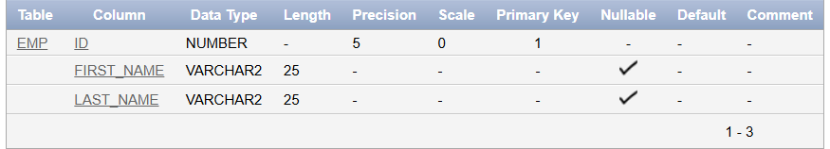

2.Create a PRIMAY KEY constraint to the DEPT table using the ID colum. The constraint should be named at creation. Name the constraint my_dept_id_pk.

CREATE TABLE DEPT (ID INT NOT NULL,CONSTRAINT my_dept_id_pk PRIMARY KEY(ID));

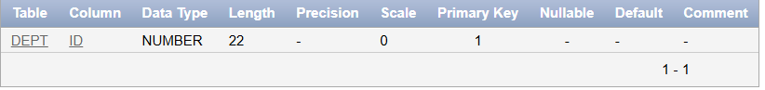

3.Add a column DEPT_ID to the EMP table. Add a foreign key reference on the EMP table that ensures that the employee is not assigned to nonexistent deparment. Name the constraint my_emp_dept_id_fk.

CREATE TABLE DEPARTMENTS(ID INT PRIMARY KEY );

ALTER TABLE EMP ADD DEPT_ID INT ADD CONSTRAINT my_emp_id_fk FOREIGN KEY (DEPT_ID ) REFERENCES DEPARTMENTS (ID);

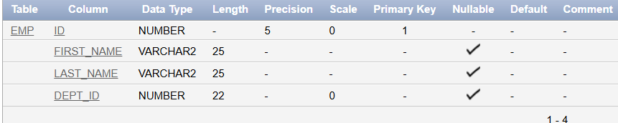

4.Modify the EMP table. Add a COMMISSION column of NUMBER data type, precision 2, scale 2. Add a constraint to the commission column that ensures that a commission value is greater than zero.

ALTER TABLE EMP ADD COMISSION NUMBER(2,2) CHECK (COMISSION>0);

